Chapter 14, Solution 9.

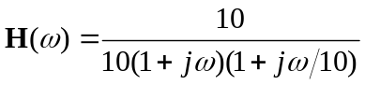

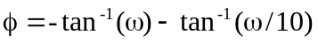

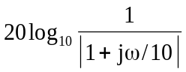
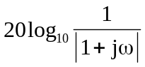
The magnitude and phase plots are shown below.
20
H_{dB}
0.1
-40
w
100
1
10
-20
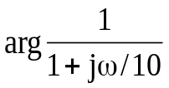
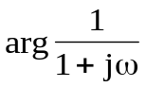
f
-135°
-45°
w
100
1
10
0.1
-180°
-90°

